# Downy Birch

## Beith chlúmhach (Betula pubescens)

There are two types of birch in Ireland, downy and silver. The most usual is the downy birch, which like silver birch is a delicate tree with fine branches and small leaves. The springtime flowers are catkins which stay on the tree and contain the mature seed by autumn.  
Birch will grow in poor soils, but likes a sunny position. Downy birch is tolerant of wet sites, but silver birch needs good drainage. Birch woods occur widely, especially on marginal soils, lake edges, such as Lough Ennell Co. Westmeath, fens and on dried out bogs such as Ardkill Bog, Co. Kildare. Birch is typically associated with the Sperrins, growing in peat at the edge of bogs, and on the light sand and gravel soils.  
It makes a good ornamental garden tree, as it does not grow too large. Like alder, its seeds are popular with small seed-eating birds such as siskin and redpoll. In early times toghers or walkways, usually across bog land were made from birch. Nowadays, it is more commonly used in making plywood.

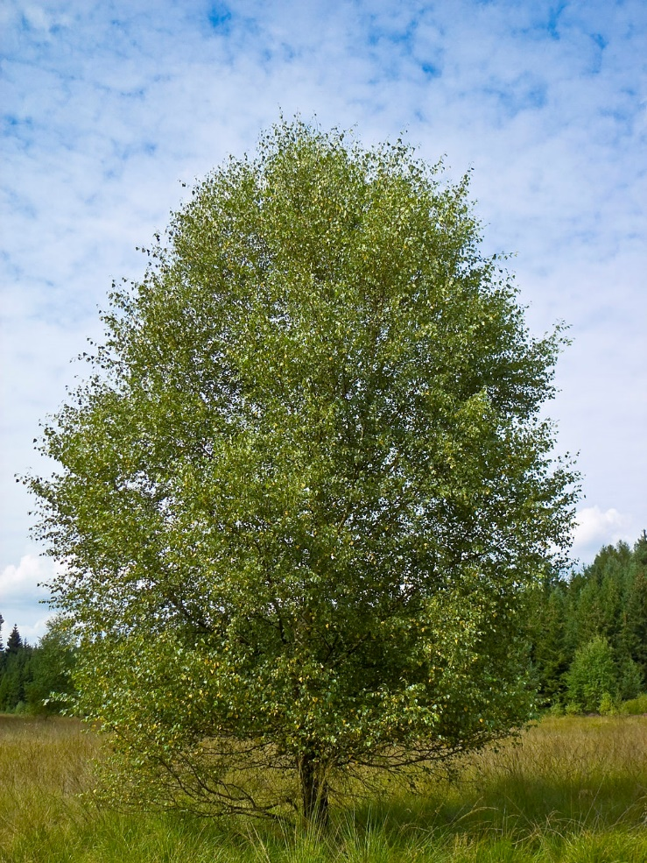

Mature tree –

**Flowers and Fruit**

Downy Birch is monoecious, it produces both male and female flowers on the same tree. The flowers appear at the same time as the new leaves in the spring

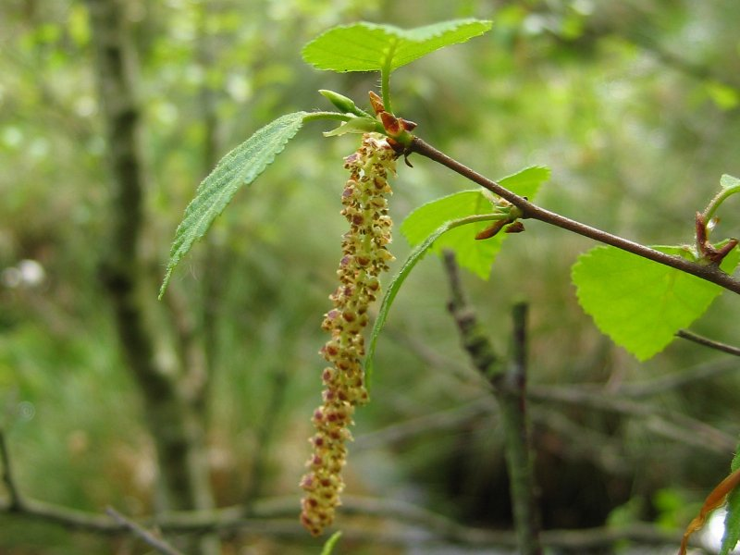

### **Bark**

The bark is usually bright in colour, reddish brown on very young stems and becoming whitish with age. It is characterized by the long horizontal streaks of grey lenticels.

.

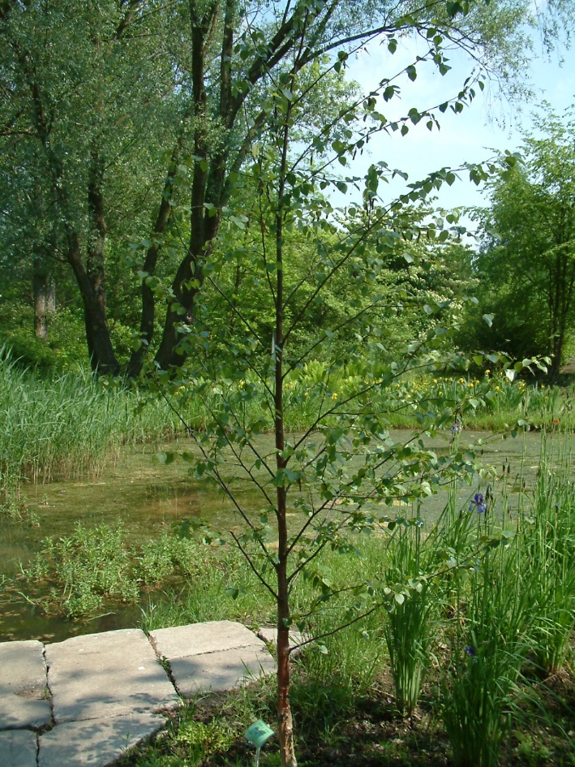Young bark

Mature Bark

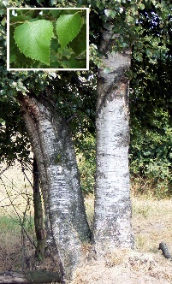

### **Leaves**

A Simple leaf that is roughly triangular with rounded corners . The leaves are 2 to 5 cm long and 1.5 to 4.5 cm broad, with a margin that is quite toothed

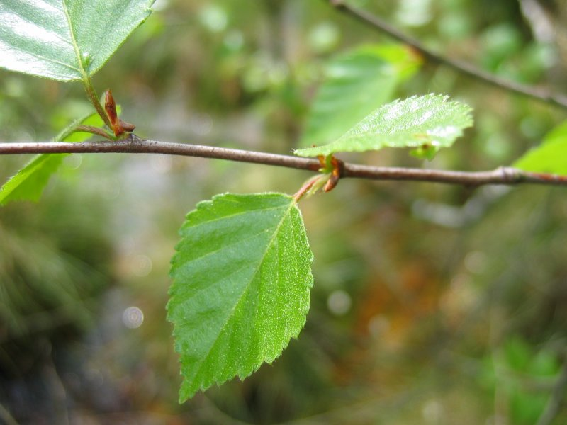

Botanical Illustration

